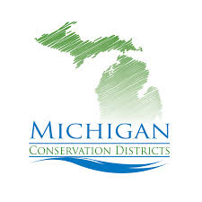Advocacy Tools: Building Relationships with Legislators
Tips:
- Remember, they are just people!
- Listen first & find common ground
- Get to the point of your visit
- Highlight your specific programs/projects
- Practice! Be prepared before you go

1) Who are my legislators (county commissioners or township officials)? What’s their coverage area? What committees do they sit on or chair?

2) How do I build a relationship with them? What does this look like? How long will it take?

3) What is the topic(s) for our meeting?

4) What questions should I ask?

5) What do they care about that I can assist with? How can I be their go to for their conservation/natural resource concerns?

